For week 4 lab, in the first exercise, I ran into an issue where the prompt would print in the same thread as the enter message. To fix this I can use a lock, to synchronize the print statements and ensure that the input prompt appears correctly.
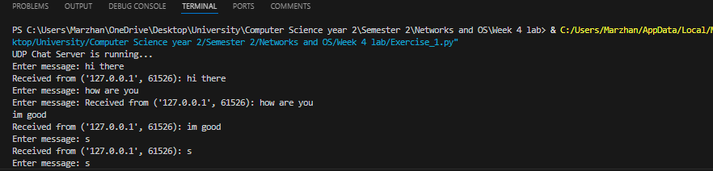

I tweaked the code so that I can use a “print_lock” to ensure that the print statements from different threads do not interfere with each other.
